Note: Some commands’ have a combined screenshot

1. Set your username and email in git config.



1. Create a new branch named "feature-branch" and switch to it.



1. List all branches in the repository.



4) Delete the branch “feature-branch”



5) How do you undo the last commit

6) Create a new branch names “conflict-branch”

7) Create a another branch named “feature1”

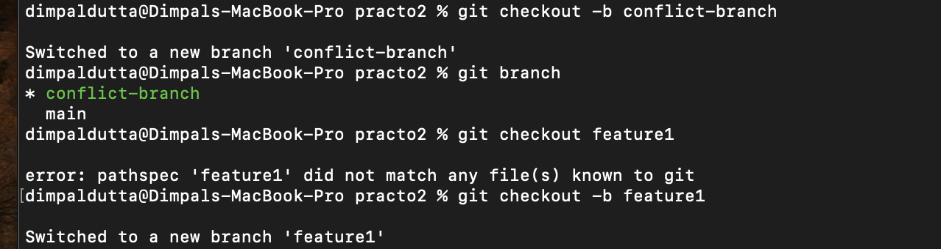

8) Make some changes in to feature1 branch

9) Merge “feature1” branch into main branch

10) Make changes in “conflict-branch”, in the same file and line that you had made changes in feature1.

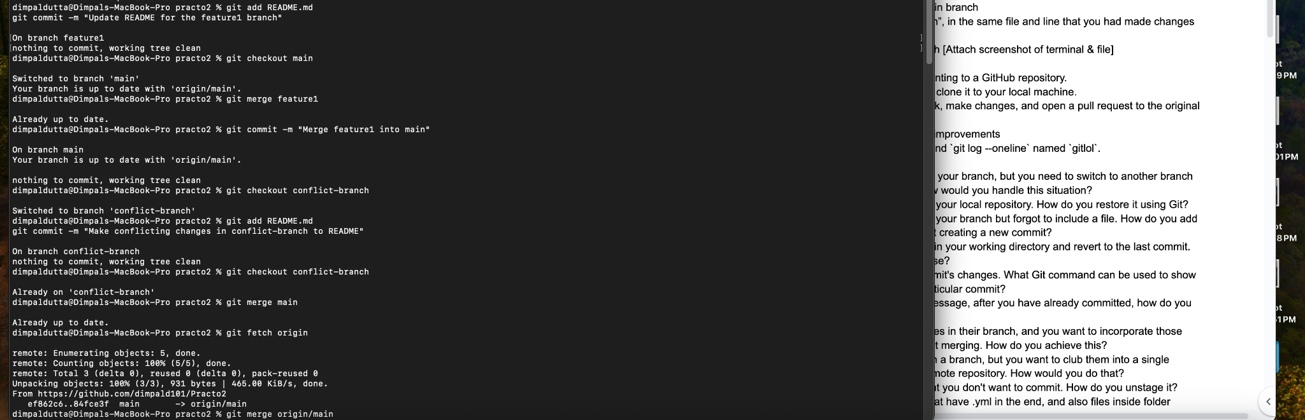

11) Merge master into conflict-branch [Attach screenshot of terminal & file]



12) Resolve merge conflicts

13) Add a remote named "origin" pointing to a GitHub repository.

14) Fork a repository on GitHub and clone it to your local machine.

15) Create a new branch on your fork, make changes, and open a pull request to the original repository.

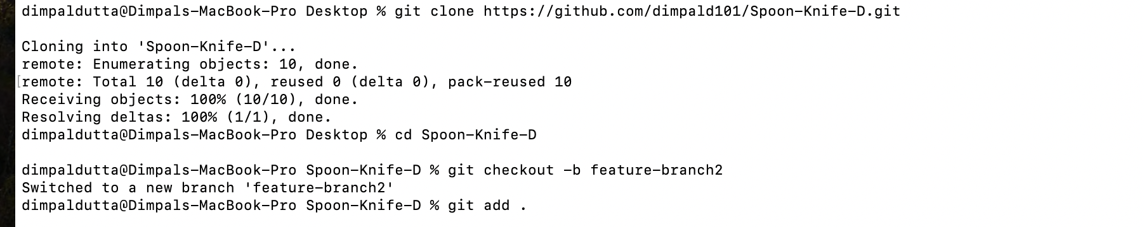

16) Comment on a PR and suggest improvements

17) Create a Git alias for the command `git log --oneline` named `gitlol`.

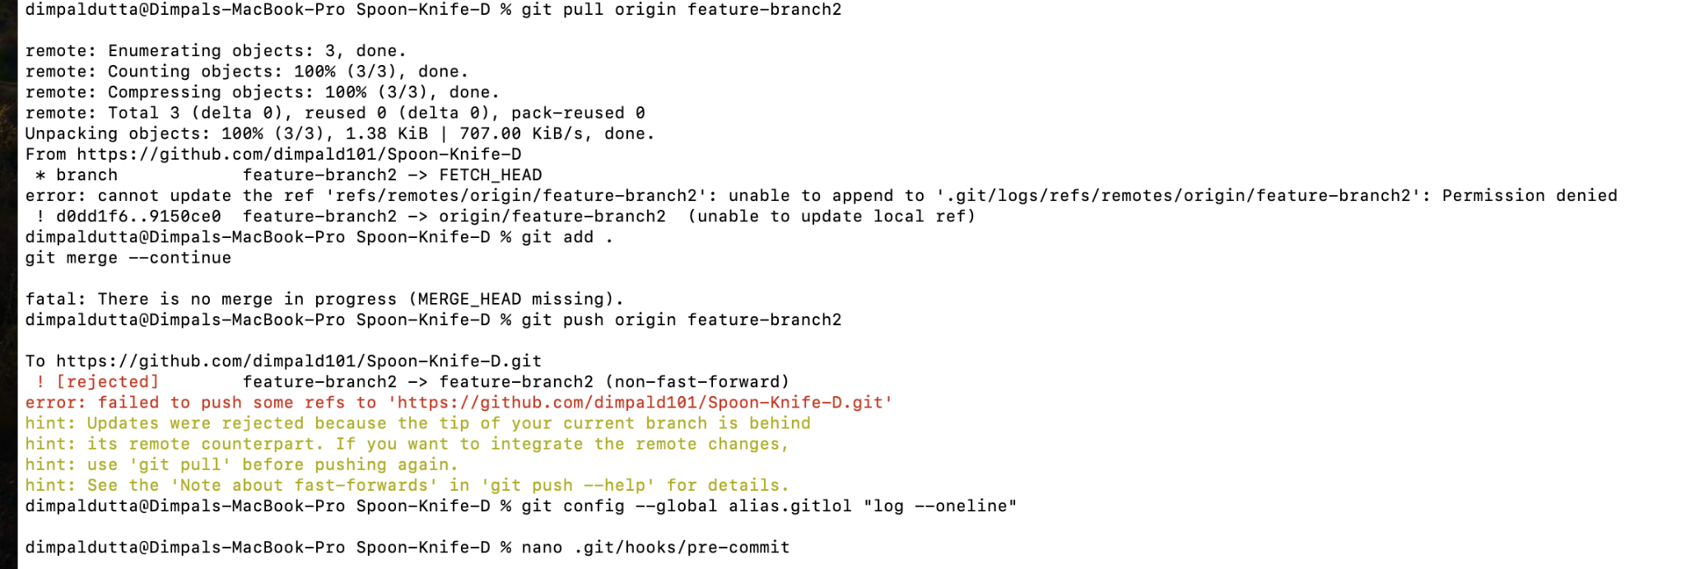

18) Create a pre-commit hook

dimpaldutta@Dimpals-MacBook-Pro Spoon-Knife-D % nano .git/hooks/pre-commit

19) You have made local changes in your branch, but you need to switch to another branch urgently without committing. How would you handle this situation?

Using a method called Stashing. Stashing allows us to save your changes without committing them. We can switch to another branch and then reapply your changes later. Command : git stash

20. You accidentally deleted a file in your local repository. How do you restore it using Git?

git checkout -- filename

//after we have identified the deleted files

21. You have committed changes to your branch but forgot to include a file. How do you add the file to the last commit without creating a new commit?

git add forgotten_file

git commit --amend --no-edit

22. You want to discard all changes in your working directory and revert to the last commit. What Git command would you use?

git reset --hard HEAD

23. You need to view a specific commit's changes. What Git command can be used to show the changes introduced by a particular commit?

git show commit_hash

24. You want to change a commit message, after you have already committed, how do you do so?

git commit --amend -m "New commit message"

25. Your colleague has made changes in their branch, and you want to incorporate those changes into your branch without merging. How do you achieve this?

git cherry-pick commit_hash

26. You've made several commits on a branch, but you want to club them into a single commit before pushing to the remote repository. How would you do that?

git rebase -i HEAD~n

27. You accidentally staged a file that you don't want to commit. How do you unstage it?

git restore --staged unwanted_file

28. You don’t want to commit files that have .yml in the end, and also files inside folder config. How do you do that?

git add -- :!*.yml :!config/

29. You want to see a list of all the files changed in the last commit. What Git command would you use?

git diff --name-only HEAD^

30. You realize that your local branch is outdated, and you want to fetch the latest changes from the remote repository. How do you do this without merging?

git fetch origin branch_name

31. You accidentally deleted a branch. How do you recover it?

git reflog

git checkout -b recovered_branch commit_hash

32. You want to remove untracked files and directories from your working directory. What Git command would you use?

git clean -fdX

33. You have a commit from a feature branch that you want to apply to the main branch without merging the entire feature branch.

git checkout main

git cherry-pick commit_hash

34. You mistakenly committed a change to the wrong branch and need to apply that commit to the correct branch.

35. There is a series of commits on a feature branch, but you only want to cherry-pick a specific range of commits.

git cherry-pick start_commit^..end_commit

36. You want to clone a GitHub repository onto your local machine, but you only need a specific branch. How can you achieve this?

git clone -b branch_name repository_url

37. You've made changes to your local repository and want to push them to your fork on GitHub. What Git commands would you use?

git add .

git commit -m "Your commit message"

git push origin your_branch

38. You want to create a new branch both locally and on GitHub to work on a new feature. What commands would you use?

git checkout -b new_branch

git push origin new_branch

39. You want to see the commit history of a GitHub repository. How can you do this using Git commands?

git clone repository_url

cd repository_directory

git log

40. You've accidentally committed sensitive information and want to remove the commit from both your local and remote repositories on GitHub. What commands would you use?

git log # Identify the commit hash

git revert -m 1 commit_hash

git push origin branch_name

41. You want to delete a remote branch on GitHub. What Git command would you use?

git push origin --delete branch_name

42. Create a git repository for all your assignments and upload them in it. Ask your peers to code review it, and you need to code review your peers assignments.

43. Create a pull request on any open source library on github, attach the pull request link to the readme file of this project’s repository.

The open source library is <https://github.com/livecycle/preevy.git>

